SimProject Release Notes

There are four known issues with the installation and running of this version of Fissure’s project management simulation. None of these problems affect the operational results of the project simulation.

Installation Error - The first problem you may encounter is during installation (see below). The error number is 1904. Select the “Ignore” button and the installation process will successfully complete.

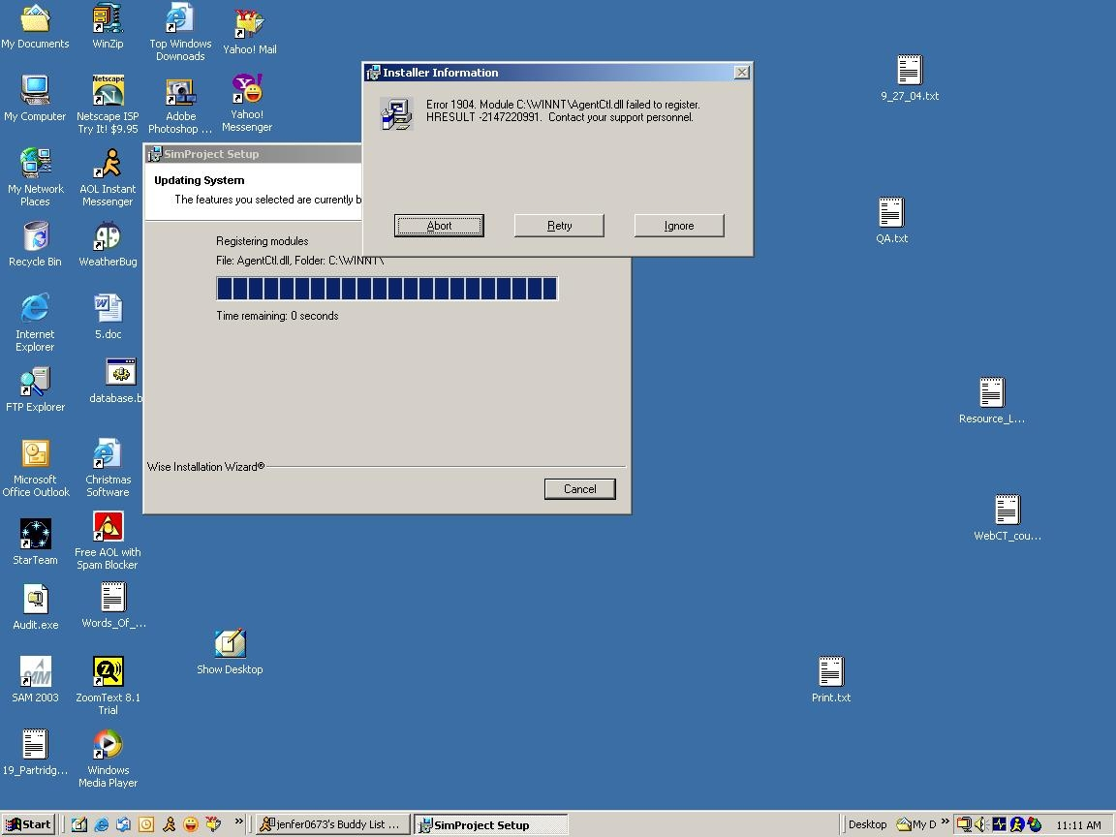

Home Button – The second problem is an error in the operation of the “Home” button within the main menu button, “References”. This button always returns the references screen to the wrong memorandum for the Alliance Prototype project. To return to the correct memorandum for the Alliance Prototype project select the “Welcome to the project” file in the “Inbox” section of the references on the left side of your computer screen.

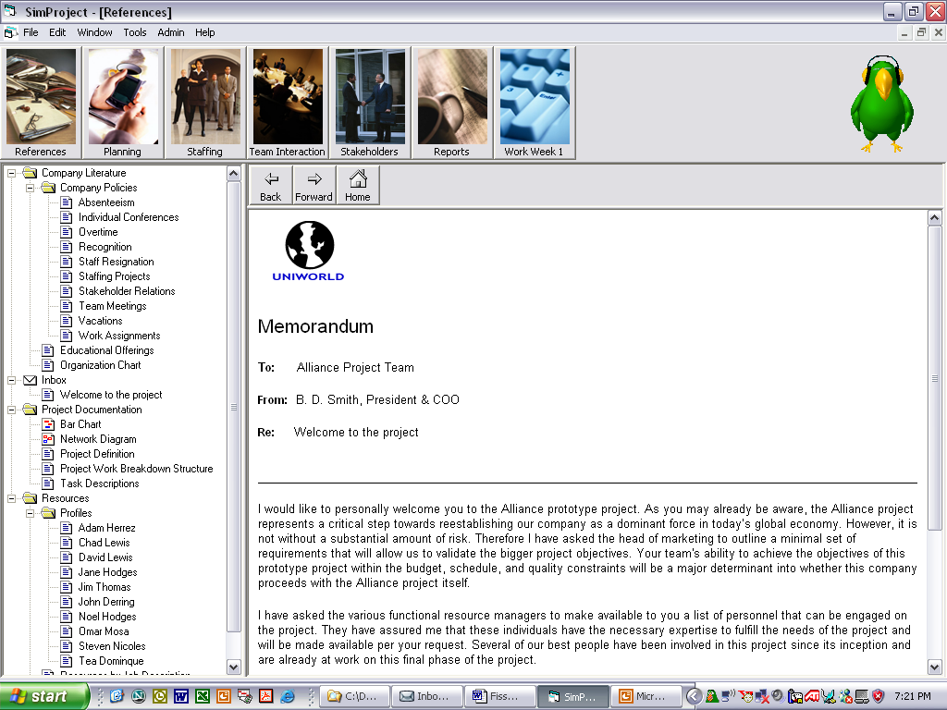

Service Pack Update
A third problem exists for users of windows 2000 who are on service pack 2. A problem which affects the operation of Fissure’s project management simulation appears to have been fixed with Service Pack Three.

- To determine your Service Pack Number:
If you are a Windows 2000 user, do the following to determine which service pack you current have installed on your computer:

Start -> Settings -> Control Panel -> System
Select the “General” Tab if it is not already selected.
You will see the version of Windows 2000 and Service Pack you are running.

- To update your service pack:
Visit the following Web Site
www.microsoft.com/windows2000/downloads

Once the page loads, scroll down the page until you see the section titled
Windows 2000 Service Packs
Click that link and follow the instructions.

- To be proactive:
The following is not related to the running of the Fissure project management simulation software; however, many people are not aware that they can receive the latest Windows 2000 updates automatically whenever updates become available. (Security Loopholes are constantly being fixed by Microsoft).
Visit the Web Site:
www.microsoft.com/windows2000
Then scroll down the page until you see the section titled
Get Security Updates Automatically
Click that link and follow the instructions.

Read-only data
A fourth problem exists if the database files in the SimProject folder are flagged as “read only”.

- To insure that the database files are NOT read-only:
Navigate to the folder where SimProject is installed. This will usually be
C:\Program Files\SimProject
Right click the folder labeled SimProject then click Properties (at the bottom of the popup menu)
Select the “General” tab if it is not already selected.

  - If the Read-only attribute has a checkmark in the checkbox:
1) Click the read-only checkbox to remove the checkmark.
2) Click the Apply button.
A window will appear with two options.
3) Select the second option labeled “Apply changes to this folder, subfolders and files”
4) Click Ok

  - If the Read-only attribute does NOT have a checkmark in the checkbox:
(You will have to turn ON read-only and then turn it off again!)
1) Click the Read-only checkbox to place a checkmark.
2) Click the Apply button.
A window will appear with two options.
3) Select the second option labeled “Apply changes to this folder, subfolders and files”
4) Click Ok
5) Click the read-only checkbox to remove the checkmark.
6) Click the Apply button.
A window will appear with two options.
7) Select the second option labeled “Apply changes to this folder, subfolders and files”
8) Click Ok

